Union assignments

Mandatory
- Refer the code below and comment on size of the given structure considering
  - Structure as union
  - Structure as struct
  - arr
  - uarr

___ Job
{
char name[32];
unsigned short ucount;
float salary;
int workerNo;
char *orgname;
};

___ Job myvar; //could of union or of struct
Struct Job arr[10];
Union Job uarr[10];
- a. 32 bytes
b. 46 bytes
c. 460 bytes
d. 320 bytes
- Refer Job datastructure in Q#1 above. Using uarr, perform below operations.
  - Read and store salary
  - Read and store workerNo
Comment on values of output if salary and workerNo are printed in order. Justify your statement.
- Code:
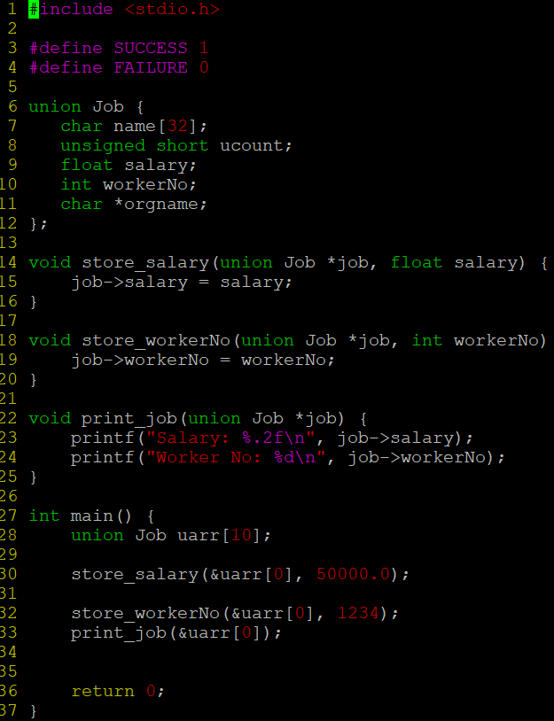
Output:
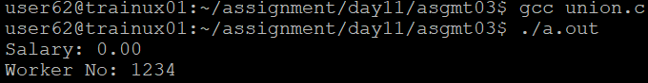

- Refer Job datastructure in Q#1 above. Assume that myvar is a structure variable. If I need to place 2 bytes (i.e 0x0102) as ucount using a char *ptr then list all possible statements that can be used in _____.
[Let solutions include cases such as
    - using base address of ucount
    - using relative address of ucount w.r.t to base address of myvar]
int main()
{
char *ptr = &myvar;

___________ = 0x01;
___________ = 0x02

}

- Code:
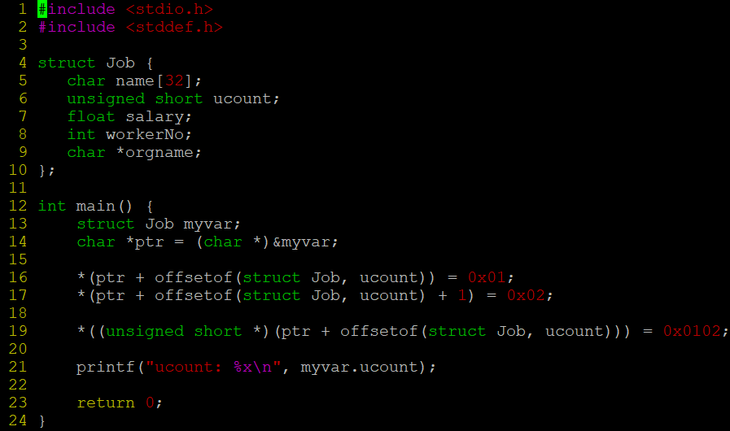
Output:

